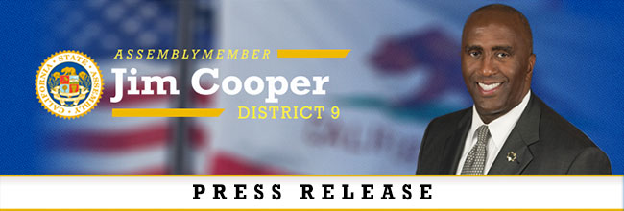
FOR IMMEDIATE RELEASE Contact: Skyler Wonnacott
April 17, 2020 Skyler.Wonnacott@asm.ca.gov
(916) 960-3951

What Community Members Say about AB 664 – Emergency Legislation

"COVID-19 is an unprecedented public health crisis and firefighters are on the frontlines answering the call with our brothers and sisters in law enforcement and health care. We commend Assemblyman Cooper and Assemblywoman Gonzalez for their work to protect these brave men and women, who are serving their fellow Californians at the risk of their own health and safety."
- Brian K. Rice, President, California Professional Firefighters

"As of April 16, 2020, there are 2,974 confirmed positive COVID-19 cases of nurses and health care workers, and four tragic fatalities among nurses in California. These deaths could have been prevented if only nurses had been provided with the proper equipment to protect themselves. While this pandemic is historic, our work is not. While most of the world shelters in place, nurses courageously enter the front lines putting themselves in harm's way to continue to care for the sick. I am honored to do this work every day, but we are putting ourselves in real danger. It is time to change the worker's compensation system to benefit nurses rather than big employers. We want to take care of the sick, but when they themselves fall ill because of their daily sacrifices, we should all provide them with the security written into AB 664. Protect nurses now so they can keep taking care of your friends and families during this pandemic."
- Zenei Cortez, RN and Co-President, California Nurses Association

“Deputy Sheriffs and law enforcement in general are stepping up to protect their community and working unprecedented hours in tough conditions with little to no protective equipment. We’re only able to face these tough risks because we know the community has our back and will take care of our families in a time of need like they did after 9/11.”
- Ron Hernandez, President, Association for Los Angeles Deputy Sheriffs

“Our peace officers are already putting their health and safety on the line every day they show up to protect our communities; they should not be doing so with uncertainty whether California will have their back if they contract this deadly disease,”
- Craig Lally, President, California Coalition of Law Enforcement Associations

###

