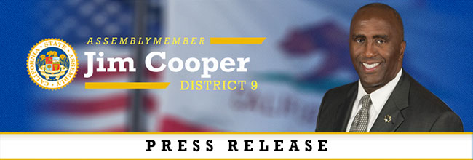
FOR IMMEDIATE RELEASE Contact: Skyler Wonnacott
April 17, 2020 Skyler.Wonnacott@asm.ca.gov
(916) 960-3951

Assemblymembers Cooper, Gonzalez and Bonta Introduce Emergency
COVID-19 Legislation to Protect First Responders and Healthcare Workers

SACRAMENTO, CA – Assemblyman Jim Cooper (D-Elk Grove), Assemblywoman Lorena Gonzalez (D-San Diego) and Assemblyman Rob Bonta (D-Oakland) announced the introduction of Assembly Bill 664 in response to the ongoing COVID-19 crisis to protect California’s firefighters, peace officers, and healthcare workers.

“Every day our first responders and healthcare workers are on the frontlines fighting to keep us safe and healthy,” said Assemblymember Jim Cooper. “These workers not only show up to protect us, but they are asked to go toward the risk while most of us are asked to stay away from it. They are heroes and should have the peace of mind that they will be taken care of if they fall ill while providing their vital services to the public,” added Cooper.

AB 664 will ensure that first responders and healthcare workers that are at a heightened risk of exposure to COVID-19 while performing their job duties will be eligible for workplace protections if they fall ill to COVID-19 or any other communicable disease when a state or local government state of emergency is declared.

“This pandemic has put our first responders and frontline healthcare workers at the forefront of the country’s biggest modern crisis,” said Assemblywoman Lorena Gonzalez. “We need to strengthen workplace protections for these heroes if they become sick while protecting the rest of us from COVID-19.”

Under AB 664, workplace protections shall include all of the following: Full hospital, surgical, medical treatment, disability indemnity, and death benefits to all peace officers, firefighters, and healthcare workers who contract COVID-19 or any communicable disease.

“Our frontline healthcare workers and first responders are putting their lives on the line every day during this pandemic,” said Assemblymember Rob Bonta. “As their work puts them at greater risk of exposure to COVID-19, these California heroes, who are selflessly working to protect and heal us, must also, be protected. They should never have to fight for the fair benefits they deserve should they contract the virus. This is the right thing to do for these brave and dedicated Californians.”

Additionally, those persons are entitled to reimbursement of out-of-pocket costs for the purchase of personal protective equipment, medical and living expenses required while performing their essential duties during a state of emergency. An employee who is eligible for compensation should not be required to use accrued vacation leave, personal leave, compensatory leave, sick leave, or any other leave, other than applicable benefits made available in order to be reimbursed.

On March 4, 2020, Governor Newsom declared a state of emergency due to the spread of COVID-19. Firefighters, peace officers, and health care workers are statutory required by the oaths they take to provide vital services during state of emergencies, placing them at heightened risk of exposure to and death from COVID-19. Because of the heightened risk to our most essential workers, it is necessary that this act take effect immediately as an urgency clause.

AB 664 is sponsored by the Los Angeles Police Protective League, Association for Los Angeles Deputy Sheriff’s, California Professional Firefighters, and the California Nurses Association.

###
Assemblymember Cooper represents the Cities of Sacramento, Elk Grove, Galt, and Lodi.

